**ROLE OF MEDICINE PATENT POOL (MPP) IN RESOLVING CONFLICT BETWEEN PATENTS ON PATENTS AND ACCESS TO ESSENTIAL MEDICINES**

**Abstract**

*This paper analyses the issue from both international intellectual property law and access to medicine with reference to contributions made by Medicine Patent Pool (MPP), an alternate model of resolving conflict between patent protection of medicines and access to medicine. Adoption of Trade-Related Aspects of Intellectual Property Rights (TRIPS) Agreement, under framework of World Trade Organisation (WTO), has significantly altered the enforcement standards of intellectual property rights, especially patent rights (Halewood, 1997). Although, TRIPS Agreement introduces minimum standards of intellectual property rights protection but in case of pharmaceutical patents, they have impact on access to essential medicines because of strict standards (Kojo, 2018). This paper aims at analysing role of MPP towards solving conflict between patents on medicines and access to medicine.*

*Keywords: Medicine Patent Pool, WTO, TRIPS Agreement, medicines, access*

**Medicine Patent Pool (MPP); an introduction**

Medicine patent pool was founded during 2010 by UNITAID with an aim to create access to medicine. Fundamental focus of the pool was resolving issue of HIV/AID medicines to populations living in less-developed countries. Later, domain of the pool was extended to paediatric medicines and in 2015 Hepatitis and TB was included in scope of the pool. Objective of MPP is to accelerate generic medicines to provide affordable medicines to patients. From its inception, MPP has been successful in providing 13 HIV/AIDS medicines, 2 hepatitis treatments, and one remedy for TB. Following part of the chapter will analyse working of MPP.

**Background of Medicine Patent Pool**

Fundamental inspiration behind establishment of Medicine Patent Pool (MPP) was availability crisis of AIDS medicine to poor population living in Africa and other developing countries in the world (Cox, 2012). WHO recommended antiretroviral (AVR) therapy was gradually improved in result of expensive research and development by various companies. Effective available solutions for HIV were very costly as they were under strong patent protection regime after adoption of TRIPS Agreement (Cox, 2012). Medicins Sans Frontier (MSF) set on aim of providing AVR to almost 14, 0000 affected people with the help of generic manufacturing in India bringing price of AVR down to USD 90 from USD 12000 (Cox, 2012). Moreover, invent of triple therapy, bringing three different medicines into one, made the task convenient. Access to medicine was again hampered by full fledge enforcement of global pharmaceutical patent protection in 2005 which once again raised the prices of effective available treatment for AIDS. MSF along with WHO constantly kept an eye on HIV and its impact on right to health and life in the world. Both organisations led different products in various countries of Africa to fight fatal disease of HIV. Efforts of MSF and WHO assisted in solving issue of access to effective medicine but barriers such as poverty, technological incapacity, and most significantly global pharmaceutical patent standards hindered the effectiveness of various measures (WHO, 2012). Moreover, in case of non-compliance of very technical standards of issuance of compulsory licensing, issuing state may face retaliatory measures from developing states as discussed earlier in this paper (WHO, 2012).

To deal with access barriers under global patent regime, an effective solution was required to deal with restricted use of compulsory licensing and limited definition of patentability under TRIPS enforcement (WHO, 2012). At this point of time, Medicins Sans Frontiers entered presented its ideas for resolving access crisis to Ministry of Foreign Affairs in France. Same proposals were also submitted to UNITAID for their consideration. The main challenges in the way of access to antiretroviral therapy to affected people were economic and legal. MPP is a model proposed to solve both issues. MSF conceived idea of MPP in its papers submitted to Foreign Affair Ministry of France and later to UNITAID. First focused government use of patents for non-commercial purposes and the second discussed and proposed patent pools. First paper deliberated the need of UNITAID purchase of AVRs from most affordable source in line with TRIPS flexibilities and Doha Declarations with the basic idea of protecting public health and public interest (WHO, 2012). Second proposal was to create medicine patent pool to address the issue of access to medicine for HIV positive population with accessibility, affordability, and availability problems. Fundamental idea was registration of drug under patent with pool. The pool further licences same for production to various manufacturers on market competition and in return paying incentive to patent holder as royalty or compensation. This idea was to bring balance between concepts of patent protection in line with protection of public health as public interest.

**Fundamental Working of Medicine Patent Pool**

Medicine Patent Pool is an idea further developed on the same analogy of health impact fund. It shares same objectivity as explained in HIF. The pool is established under UNITAID. It works for patients and developing countries and utilises patent monopolies on voluntary basis establishing an adequate method of compensating for innovation. UNITAID has focused mainly AIDS and children related diseases in their impact (Bermudez, Hoen, 2010). Medicine Patent Pool is a model close to the idea of compulsory licensing with consensus instead of compulsion. The traced of development of Medicine Patent Pool go back to Barcelona AIDS Conference in 2002 when various research groups proposed establishment of the pool but it was established by UNITAID later in 2006.

It is worth noting that funding for Medicine Patent Pool was unique in a way that a specific amount of money was charged on Air-Travel contributing towards development of fund by some developed countries (Bermudez, Hoen, 2010). Functioning of Medicine Patent Pool is not complex and is very simple for understanding. Following pictorial format is best to describe it:

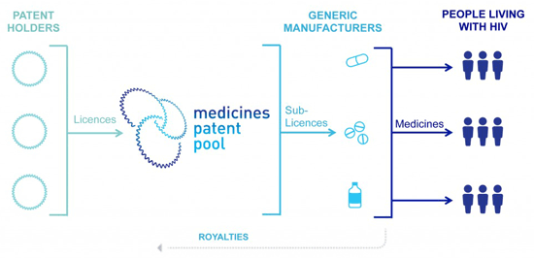

The picture is taken from work of Katherine Moriarty

Patent holders have freedom or are persuaded in some cases to register their innovation in drugs with Medicine Patent Pool. The pool further sub-licenses the same medicine to generic manufacturers and later it creates market competitions. Generic manufacturers in return pay royalties to the pools which are given to patent holders as incentive for their innovation.

MPP will be managed by an independent body from all political, sovereign, or corporate influence. Determination of inclusion of products or medicine under operation of patent pool will follow the guidelines of WHO essential list and priority will be given on independent process of evaluation from experts. Moreover, independent process will decide redundancy of existing patents and inclusion of new patents for creation and operation of patent pool. This process including ascertaining royalty volume will be done under tight scrutiny of experts in the field. Rights of patent holders registering their products under patent pool, modalities of contract between MPP and sub-licensees, quantum of royalty, and third party rights will be decided independently on technical basis excluding all necessary biases. We may discuss here HIV drug under MPP (Bermudez, Hoen, 2010). It was decided that royalty for drug under patent pool will be decided against use and contribution of drug towards health and use of product. Another illustration for MPP working is production of combination treatment by Pfizer. Before, its operation under MPP, Pfizer needed permission from Byer and Merck, patent holders. In this case, it may cost Pfizer high cost of licensing but with authorisation of MPP, Pfizer can contribute towards access to medicine by mass production in the world. In return, it may contribute towards royalty fee that will be indirectly paid to patent holders (Bermudez, Hoen, 2010).

MPP has always kept in mind priorities of both stake-holders in paradox between access to medicine and incentive for pharmaceutical companies. Research in pharmaceutical innovation involved a great deal of investment risk where a good number of inventions are not marketable and profitable (Bermudez, Hoen, 2010). In this way, pharmaceutical companies often focus on profits out of investment in research and development of effective essential medicines.

**Medicine Patent Pool; Progress Report (2010-2015)**

After its inception in July 2010, MPP aspired to achieve its business model of public health (MPP, 2016). Initially, MPP focused HIV treatment using its method of voluntary licensing. During 2010-2015, MPP has tangibly contributed towards access to medicine for HIV treatment (Juneja, 2017). Recently, it has expanded its operation to other fatal diseases such as tuberculosis and malaria. Statistically, MPP has contributed by 12 AVRs from six patent holders and further sub-licensing them to 59 companies for production in 117 countries (Juneja, 2017). Low prices of AVRs have saved USD 79 million and further aim to achieve USD 1.4 billion (Juneja, 2017). Following figure demonstrates MPP acheivements during 2010-15 (Hoen, 2017):

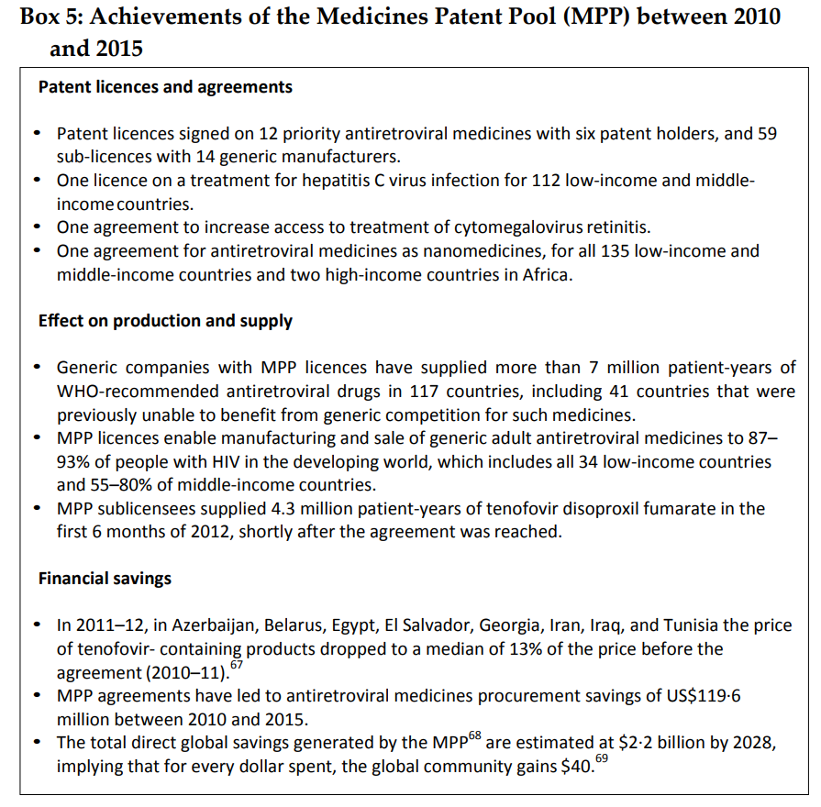

MPP initially focused on AVRs for strict pharmaceutical patent regime under TRIPS Agreement and its anticipated impact on generic manufacturing of AVRs in China and India. Among most significant development in this regard is registration of Dolutegravir, a very effective AVR for HIV. MPP effectively licensed it to facilitate effective treatment for fatal disease. MPP further entered negotiations with patent holding company, Gilead Sciences. These negotiations further improved terms for sub-licensing of AVR. MPP has also tangibly contributed towards speeding up market entry of generic medicines after expiry of patent monopoly. Generic entry of medicine usually took 10 years for effective market entry after expiry of patent duration (MPP, 2016). MPP, through its licensing negotiation with patent holding companies, has facilitated entry of generic medicines. This has been explained in following diagram:

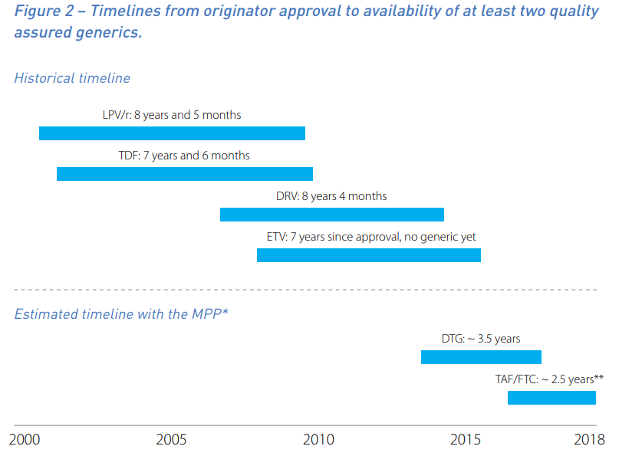

Accelerating market entry of generic medicines will help brining prices down through competition. Timeline for entry of generic in HIV is coming down to 2.5 years in 2018 from more than 8 years after enforcement of global pharmaceutical patent regime. Recently, MPP has started operating beyond HIV treatment to help reducing prices of other life-threatening diseases (MPP, 2016).

To boost generic production of essential medicines, MPP has entered into agreements with 14 leading manufacturers all over the world. Main contributors towards generic manufacturing are Chinese companies for their capacity to manufacture on low costs. Desano, HEC Group, and Huahai are preforming very diligently in generic production of AVRs to help countries with maximum victims of HIV virus (MPP, 2016).

**Overview of Licenses under Medicine Patent Pool**

First licensing under MPP was one on 30th September, 2010 by White House initiative. USA tried to accomplish presidential commitment for humanitarian support to patent licensing for ensuring access to medicine for developing countries manufactured in the country (Chen, 2010). Patent for darunavir, owned by National Institute of Health (NIH) was the first medicine registered for licensing in MPP. It was declared by US government that this contribution, “builds on the President’s previous commitment to support humanitarian licensing policies to ensure that medications developed with U.S. taxpayer dollars are available off-patent in developing countries” (Chen, 2010). Moreover, grant of licensing to MPP by NIH was without any royalty and limitation to areas of distribution. The license was open for all developing and least developed nations falling under definition of World Bank. This move by US government was appreciated by both human rights as well as pharma circles and most significantly it also favoured the goals of MPP providing access to essential medicine across world. US government generally and NIH support provided a strong foundation for progress of MPP. Example set by world’s largest bio-medics investor attracted other pharmaceutical manufacturers joining MPP.

Issue regarding enforcement of darunavir sub-licensing and production for public interest in developing countries started with the shared patent-hold of the drug by Johnson & Johnson along with NIH. Generic production of drug was only possible once the company enters into agreement with MPP. Johnson & Johnson, one of the biggest attractions for MPP for licensing HIV Medicine, remained reluctant in entering negotiations with MPP in the beginning but later on it negotiated modus of registering its patented drugs under MPP. But later on negotiations were not successful and the company did not agreed to register its drug under MPP. Move of Johnson & Johnson was criticised by human rights activists around the world based upon arguments of corporate social responsibility towards public interest and access to essential lifesaving drugs that is easily possible through registering products under MPP (Intellectual Property Watch, 2012).

Second example is Gilead registration of its multiple products under MPP on 12 July, 2011. This endeavour remained successful with greater positive impact on public interest, access to medicine, and reputation of both Gilead and MPP (MPP, 2016). Mainly, this licensing covered tenofovir (TDF), amtricitabine (FTC), elvitegravir (EVG), and COBI, a multi-formula drug famously known as ‘quad’. Agreement between Gilead and MPP covered generic production of COBI, EVG, FTC, and most significantly TDF. The agreement was impactful as it allowed transfer of basic knowledge about the products without payment of additional money to the terminal patent holder, Gilead. This licensing endeavour is unique as it grants sub-licensing company freedom in the shape of waiver in regulatory exclusivity for manufacturing and selling product in specific territory (MPP, 2016). Although agreement between Gilead and MPP seems very good in production of cheap generic medicine solving issue of access to medicine in HIV but it is also criticised based upon exclusion of countries with middle income for instance Latin American and Asian nations (Cox, 2012). Geographic scope of this agreement is limited. Although a good deal of care was made to cover most of low-income countries in the agreement but it still has some space for improvement. Besides exclusion of several countries with low income, the agreement allowed sub-licensing companies to produces and sell the product in countries where compulsory licensing was issued on the product (Cox, 2012). Article 10.3 of the agreement proposes solution as under:

*“For further clarity, and notwithstanding anything to the contrary in this Agreement, it shall not be deemed to be a breach of the Agreement for Licensee to supply an API or Product outside the Territory into a county where (i) the government of such country has issued a compulsory license relating to such API or Product allowing for the importation of such API or Product into such country, provided Licensee’s supply of Product or API into such country is solely within the scope and geographic range of such compulsory license and only for the duration that such compulsory license is in effect and/or (ii) the Government of India has issued a compulsory license allowing for the export of any API or Product from India and into such country, provided that (Y) there are no patents controlled by Gilead that contain a valid claim covering the use, import offer for sale or sale of such API or such Product issued in such country or a compulsory license has also been issued by the relevant authorities of such country and (Z) Licensee’s supply of Product or API into such country is solely within the scope and geographic range of the compulsory license issued by the Government of India and only for the duration that such compulsory license is in effect” (Cox, 2012).*

Agreement between Gilead and MPP through this provision, try to cover the gap of low income countries not covered in the agreement. Moreover, countries who issued compulsory licensing are also covered. So, this provision makes the agreement more flexible and convenient for purpose of accelerating access to medicine.

**Evaluating Performance of Medicine Patent Pool**

Basic model of MPP works by authorising generic production of newly invented medicine with the help of international organisations and pharmaceutical companies (Childs, 2010). Although, MPP has been effective to achieving goals in HIV/AIDS but TB, Malaria, and drugs for infectious diseases still pose a challenge. One of the big challenges is convincing various stakeholders to MPP such as pharmaceutical companies and governments. Recent study conducted by Jinjing Zeng finds that participation of various stakeholders such as government and pharmaceutical companies will enhance efficiency of MPP working model. The work has focused on various factors impacting productivity of MPP (Zeng, Zhang, Tang, 2018). Findings include lowering prices of generic medicines, appropriate adjustment of license fee and subsidies, and evaluation of original drug enterprise are factors that may enhance efficiency of MPP.

MPP model of licensing provides convenience to pharmaceutical companies as they are at freedom to register or not to register their product or medicine with MPP. Meaning thereby, operation of MPP is voluntary for patent holders. Cox notes that pharmaceutical companies are free to leave negotiations of licensing even there is a serious case of life saving medicines (Cox, 2012). For example, Johnson & Johnson, after negotiations, did not opt for registering its drug under MPP in the case quoted earlier. So, patent holding pharmaceutical companies are at more convenience during negotiations with MPP regarding setting terms and conditions of agreement. Negotiation between MPP and patent holders are based upon voluntary bases and there is no tool available for MPP to force or coerce any patent holder on its conditions. Keeping in mind the status of MPP during registration process of patented medicine, many factors play their role in effectiveness and success of MPP performance. Some writers defend performance of MPP on the notion of its status and further rebut the arguments of human rights activists against MPP as impractical (Cox, 2012). They argue that MPP got some limitations and those limitations cannot reach reaching ‘ideal’ performance as propagated by human rights activists. It is further contested that strict and perfect ideals contested by human rights activist will attain nothing and obstruct contribution of MPP (Cox, 2012). Support for AIDS effected people by MPP has been remarkable success and the same model has started contributing to other fatal diseases.

Fundamental criticism on working of MPP is its weak bargaining position and ignoring many low income nations of Latin America and Asia with only focus on Africa (Child, 2010). It has been argued that MPP has been used by pharmaceutical giants to gain their benefits, and during negotiations, companies use their technical expertise to win both public favour as well as profit margins. Rebutting these arguments, it is contended that percentage of covering geographical area under MPP-led licensing agreements is very wide (Gold, Morinb, 20019). Moreover, it is contested that number of people covered under MPP endeavours may be kept in mind. Impact of MPP working should be evaluated through impact on people rather geographical areas. Gilead agreement with MPP is quoted as example where largest coverage of both geographical area as well as population is achieved (Cox, 2012). Extended TDF licensing protected about one hundred thousand people infected with AIDS in comparison with the previous agreement for the same medicine. Although it is admitted that MPP is evolving and several laps are there in negotiations and agreements but they are importing with every passing day creating more convenience for patients in term of access to medicine. Gilead licensing may be taken as test case that improved with every step of negotiation between MPP and Gilead. This example has tangibly contributed towards access to medicine (Hoen, 2017).

Furthermore, licensing methodology of MPP has also eased the use of generically produced medicine beyond boarders without breaching terms of voluntary licensing. This may cover extended number of patients in other countries. For example, in Gilead licensing of its products, one of the provisions of the agreement allows export of product to countries where compulsory licensing is invoked against product under MPP licensing. Export of generically produced medicine also solves the question of coverage of other geographical areas not covered under licensing agreement. Countries, not covered under agreement, may import drug from others where MPP sub-licenses allow production of generic medicine. Specifically, this provision was introduced after Gilead licensing of its product with MPP. Moreover, Gilead agreed to cooperate with future invented medicines. Welcoming and cooperating attitude remains an example for other pharmaceutical companies and has attracted other pharmaceutical companies.

Both Cox (Cox, 2012) and Jinjing Zeng (Zeng, Zhang, Tang, 2018) conclude their analysis of MPP at one point and that is participation of other stakeholders to improve effective working of MPP model. Pharmaceutical companies may be attracted towards MPP by enhancing incentive through Donor Prize Model (Cox, 2012) and others while government may include their efforts through effective use of power of compulsory licensing (Cox, 2012). Various factors such as adequate pooling subsidies, emancipating MPP status in licence negotiations, governmental backing of MPP through compulsory licensing, and creation of more incentive for pharmaceutical companies may enhance productivity of MPP. Moreover, civil society all around the world may work for concentrating efforts of alternate models to get them organised for effectively solving issue of access to medicine.

**Concluding Remarks on Medicine Patent Pool**

Recently, Global Action Plan of WHO focuses Anti-Microbial review regarding resistances of antibiotics and calls for research and development to improve antibiotics resistance against modern diseases. Scientists, around the world, are concerned about decrease in effectiveness of antibiotics with every passing day (Perry, 2017). This decrease has aggravated health concerns against modern diseases. WHO is struggling to convince and boost research and development through generating new incentives (Bermudez, Hoen, 2010). Investment volume on research and development of advance antibiotics is estimated very high and pharmaceutical companies are reluctant to invest huge sums for the reason of risk over profits and returns (Bermudez, Hoen, 2010). Issue of risk over investment in research and development to develop advanced antibiotic medicines may be addressed with MPP and several proposals to do so are advanced by researchers in Davos during World Economic Forum meeting. Tuberculosis (TB) also poses challenge to developing countries and warns developed countries from commuting populations and infectious nature of disease. MPP can be effective for creating access to effective medicine by creating a tangible incentive system for research on the disease (Bermudez, Hoen, 2010).

Patent licensing by MPP can boost research and development of further advanced medicines around the world with protecting risk over high investments on research and development along with easing access to essential medicines. HIV model of MPP is tangible success in this regard that has performed very well in managing access issues to greater extent for both adults and children (Bermudez, Hoen, 2010). Now, MPP’s endeavours to tackle access issues in TB can further solve the issue of access to medicine. Moreover, the model may be extended to diseases with access to medicine issues around the world (WHO, 2012).

MPP may be termed as one of the efforts to find equilibrium among right to health, global pharmaceutical patent protection, protection of risk over huge research & development investments in medicine, and access to medicine. MPP fulfils the basic ideal of TRIPS Agreement saying:

“…contribute to the promotion of technological innovation and to the transfer and dissemination of technology, to the mutual advantage of producers and users of technological knowledge and in a manner conducive to social and economic welfare, and to a balance of rights and obligations” (TRIPS Agreement, 1994).

Ideals of MPP remain voluntary licensing, independent negotiations, equitably royalty, and indiscriminate efforts to solve access to medicine issues around the world. MPP respects innovation as root public interest as it leads towards increase in research and development of advanced medical remedies (Noehrenberg, 2010). Moreover, it contributes towards access to medicine by non-exclusivity, public health considerations, and market competition to bring prices affordable (Noehrenberg, 2010). MPP is focused on achieving Sustainable Development Goals and have performed brilliant in this regard. To sum up, MPP solves access to medicine issues without hampering scientific and technological research and development.

**References**

Bermudez, J., Hoen, T, H., (2010) ‘The UNITAID Patent Pool Initiative: Bringing Patents Together for the Common Good’ The Open AIDS Journal 4*,* 37-40

Childs, M., (2010) ‘Towards a Patent Pool for HIV Medicines: The Background’ The Open AIDS Journal 4*.* 33-36

Cox, L, K., (2012) ‘The Medicines Patent Pool: Promoting Access And Innovation For Life-Saving Medicines Through Voluntary Licenses’ Hastings Science & Technology Law Journal 42*.* 294, 293-326

Gold, E. R., Jean-Frédéric Morinb. (2009) ‘The missing ingredient in medicine patent pools’ The Lancet 373*.* 1329-1330

Halewood, M. (1997) ‘Regulating Patent Holders: Local Working Requirements and Compulsory Licenses at International Law’ (1997) Osgoode Hall Law Journal 35*.* 243, 259

Hillary Chen, The White House (2010) ‘US Government First to Share Patents with Medicines Patent Pool’. Retrieved from. <https://obamawhitehouse.archives.gov/blog/2010/09/30/us-government-first-share-patents-with-medicines-patent-pool>. Accessed on 3 May 2018

Hoen, T, E *et* al.,, (2017) ‘Data Exclusivity Exceptions And Compulsory Licensing To Promote Generic Medicines In The European Union: A Proposal For Greater Coherence In European Pharmaceutical Legislation’. Journal of Pharmaceutical Policy and Practice 10 (19) 1-19

Hoen, T. H, Berger, J. (2011) Alexandra Calmy, Suerie Moon, ‘Driving A Decade Of Change: HIV/AIDS, Patents And Access To Medicines For All’ Journal of the International AIDS Society 1-12, 3

Hoen, T. H., Pecoul, B., Hogerzeil, H., ‘Developing Missing Essential Medicines’ in

Veronika J Wirtz, Hans V Hogerzeil, Andrew L Gray, Essential medicines for universal health coverage. The Lancet, 2017. 403-476

Kojo, Y. (2018) ‘Global Issues and Business in International Relations: Intellectual Property Rights and Access to Medicines’ International Relations of the Asia-Pacific18 (1)*.*  5-23, 8

Medicine Patent Pool; Progress Report (2010-2015). Retrieved from <https://medicinespatentpool.org/uploads/2017/07/WEB_Progress_Report_2015_EN.pdf>. accessed on 3 May 2018

Noehrenberg, E., (2010) ‘Implications of Patent Pools on Innovation Regarding Antiretrovirals’. The Open AIDS Journal 4*.* 67-69

Perry, G. (2017) ‘Medicine Patent Pool’ Retrieved from. <http://www.unsgaccessmeds.org/inbox/2016/2/28/greg-perry>. Accessed on 5 May 2018

Sandeep Juneja, et al. (2017) ‘Projected Savings Through Public Health Voluntary Licences Of HIV Drugs Negotiated by the Medicines Patent Pool (MPP)’ PLoS One 15 (2). Retrieved from <https://www.ncbi.nlm.nih.gov/pmc/articles/PMC5444652/>. Accessed on 7 January 2018

TRIPS Agreement (1994), Article 7

WHO Report (2012) Promoting Access To Medical Technologies And Innovation Intersections Between Public Health, Intellectual Property And Trade. Retrieved from http://www.who.int/phi/promoting_access_medical_innovation/en/. accessed 2 May 2018

Zeng, J., Zhang, W., Tang, Q., (2018) ‘Analysis of the Factors Influencing Enterprise and Government Participation in the Medicines Patent Pool Based on System Dynamics Model’ Iran Journal of Public Health 47 (10)*.* 1493-1503, 1493

Retrieved from <http://www.who.int/phi/implementation/10_summary_EN.pdf>. Accessed on 3 May 2018